**Mega Awesome Manual**

**Version 1.0**

Contents

Chapter 1, Introduction 3

Welcome to Mega Awesome 3

Software Compatibility 3

Chapter 2, Running One Ring 4

Running from Lab View (.vi) 4

Running from an executable (.exe) 4

Chapter 3, Using One Ring 5

The One Ring Workspace 5

One Ring Tab Structure 5

Super Duper 5

Overlord 5

TPX Control 5

Apple 5

# Chapter 1, Introduction

## Welcome to Mega Awesome

Thanks for using Mega Awesome as your choice for analyzing data in your transistor research. Hopefully its use will or has already expedited your research and has begun to limit the error involved in analysis. Mega Awesome was built in conjunction with its data capture counterpart, One Ring. Please enjoy that software package as well to continue your transistor analysis and discovery.

Mega Awesome comes from a line of Lab View programs used in the OE Group laboratory at Wake Forest University. First was the program build by Pete Diemer that was used as a tool for the automation of calculating the mobility from a text file of transistor data. This quickly expanded into a much more involved program called Mega Awesome. This initial version was used by many group members until it was expanded yet again in the summer of 2012 to calculate a larger set of parameters from the electrical data and included a more efficient integration with OriginLab software.

This manual is provided to orient yourself with the basics of Mega Awesome so that you can begin using just as soon as you’re through.

## Software Compatibility

Mega Awesome is built to be used only with data taken using either Super Duper or One Ring programs built within the OE Group. The formats and text within these file structures are built in such a way that they are compatible with each other and other formats are not guaranteed to work. Additionally, the beauty of having the original Lab View .vi files avaibale is that a person experienced in working with Lab View can modify the software to meet any of their needs.

Lastly, the files that are outputted are saved as tab-delimited files and have been intended to be ready either by your favorite text-editor (we recommend Notepad++). As a user will likely want to see one of a variety of trends pertaining to their electrical measurements, Mega Awesome is intergraded to export to specific OriginLab template project. Therefore, one must have this software and template installed prior to using the export capabilities of Mega Awesome

# Chapter 2, Running Mega Awesome

## Running from Lab View (.vi)

One Ring’s most current version as saved as a native Lab View file (.vi). Please take care when structural changes are made to the .vi, as and change could be permanent and prevent functionality for other users. If drastic changes will be made, please make a new version of the software for your use with a different name.

To run the most current version of the software, simply double-click on the .vi and a Lab View screen will open with the Mega Awesome displayed. At this point, the “**Run**” arrow must pressed initiate the program. Now, the software is running and should ready to analyze your data.

## Running from an executable (.exe)

Mega Awesome also comes in an executable format for those not want to use the Lab View interface. This version prevents users from being able to change/edit the software but is still fully functional. To run from the .exe, simply double click on the Mega Awesome icon and the program will open. Once open, the user may begin analyzing.

# Chapter 3, Using Mega Awesome

## The Mega Awesome Workspace

When you start Mega Awesome, you will see the **Sample Properties** tab displayed (See Figure 1). This is one of the multiple tabs within the workspace.

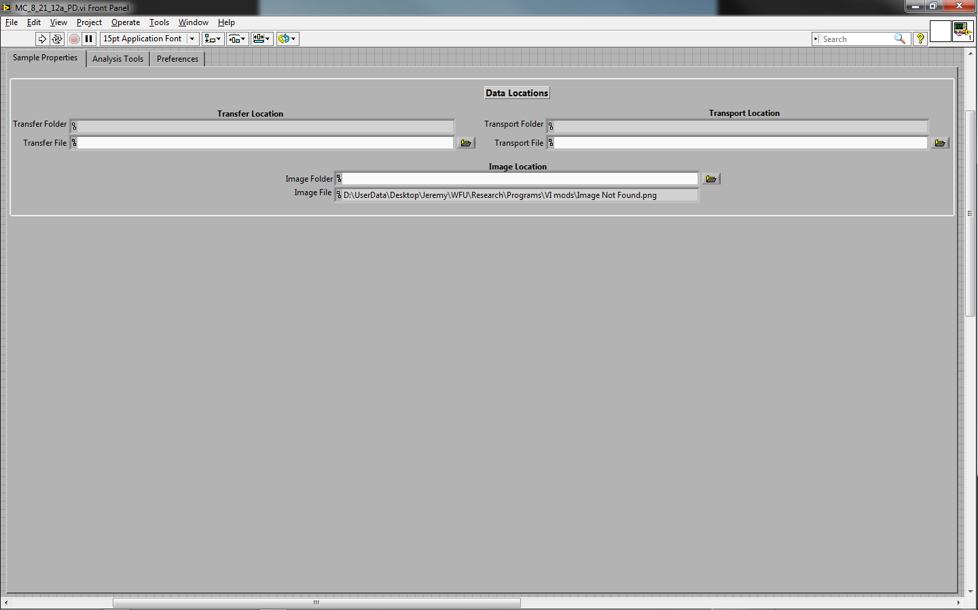

Figure : The Mega Awesome opening workspace

## Mega Awesome Tab Structure

Mega Awesome’s tab structure allows for a clean look and efficient navigation of the program. Tabs can be selected simply by clicking on the name located within them. This will display the contents of the tab selected.



Figure : The tabs used to organize the tools

### Sample Properties

### Analysis Tools

### Preferences

### 